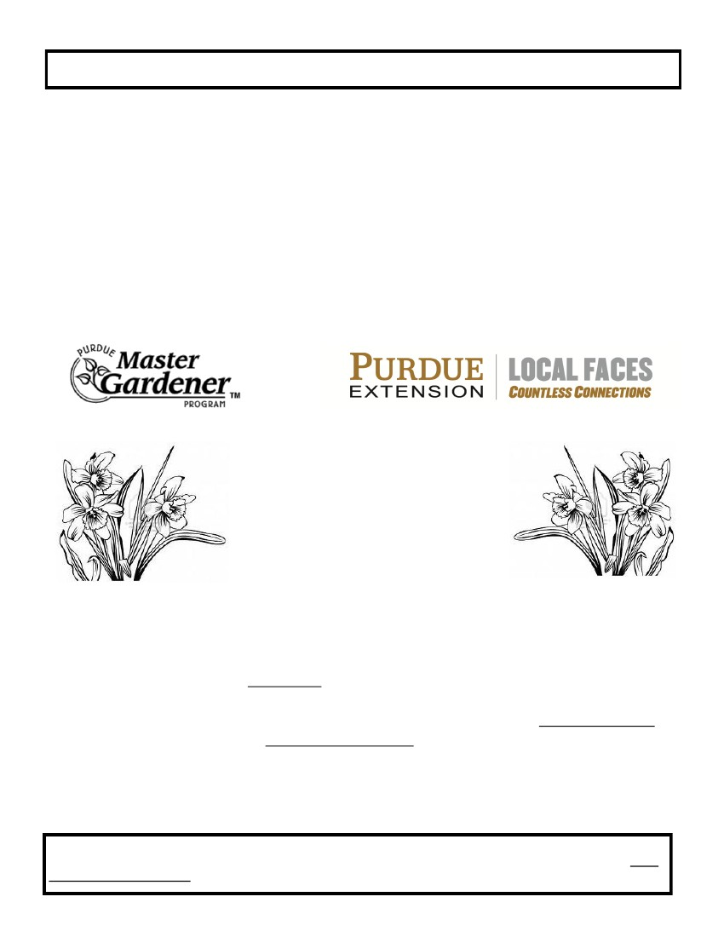
Non-Profit Organization Information
Are you looking for an effective way to reach enthusiastic?
Gardeners with information regarding your services?
The solution is….
GARDEN EXPO 2015
Presented by:
AND
Saturday, April 25, 2015
9:00 am — 3:00 pm
Tippecanoe Co. Fairgrounds
1010 Teal Road
Excited gardeners attending Garden Expo 2014 will not only be looking for sources of
quality plants, gardening tools, essential supplies and new items; but, they will also be
looking for other information and/or services pertaining to your organization.
Non-profit organizations WILL NOT be charged for a booth. Please note, all booths are
required to be staffed; there will be no unmanned booths this year. You will be responsi-
ble for booth set-up and tear–down. Each booth will have electricity. Limited spaces ,
assigned on a first come basis one space per group. Tables and chairs are available up-
on request. Booth set-up will be held on Friday April 25, (3:00 pm—6 :00 pm) and Satur-
day, April 26th, (7:00 am –10:00 am). Booths must be torn down between 3:00 pm and
5:00 pm. Please respond by April for1st for a choice location.
Note: We are endeavoring to compile an accurate list of organizations, complete with the appropriate contact person’s name for
each organization. If you receive this in error, PLEASE FORWARD THIS LETTER AND APPLICATION TO THE COR-
RECT CONTACT PERSON for your establishment. Thank You !!

